Excercise-1- Mocking and Stubbing

1. MyService.java

package org.example;  
  
public class MyService {  
 private ExternalApi api;  
  
 public MyService(ExternalApi api) {  
 this.api = api;  
 }  
  
 public String fetchData() {  
 return api.getData();  
 }  
}

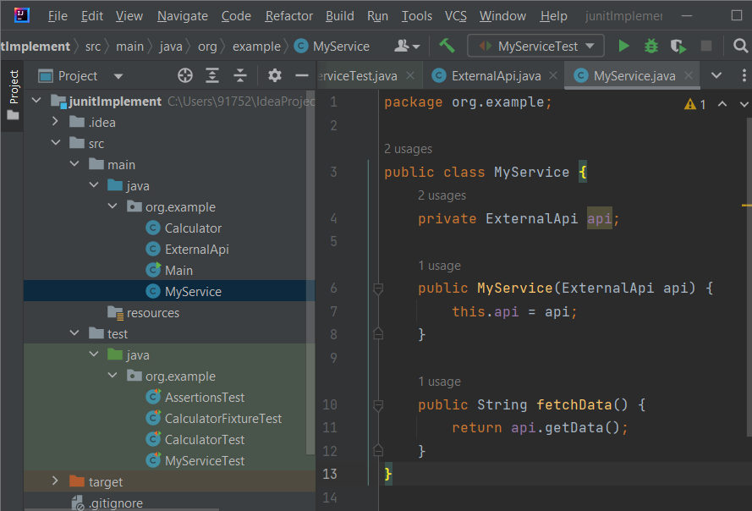

1. MyServiceTest.java
2. public class MyServiceTest {  
     
    @Test  
    public void testExternalApi() {  
    // Step 1: Create mock  
    ExternalApi mockApi = Mockito.*mock*(ExternalApi.class);  
     
    // Step 2: Stub the method to return "Mock Data"  
    *when*(mockApi.getData()).thenReturn("Mock Data");  
     
    // Step 3: Inject mock into MyService  
    MyService service = new MyService(mockApi);  
     
    // Step 4: Call method and assert the result  
    String result = service.fetchData();  
     
    // Step 5: Assert  
    *assertEquals*("Mock Data", result);  
     
    // Step 6: Verify interaction  
    *verify*(mockApi).getData();  
    }  
   }

3-ExternalApi.java

package org.example;  
  
public class ExternalApi {  
 String getData() {  
 return null;  
 }  
}

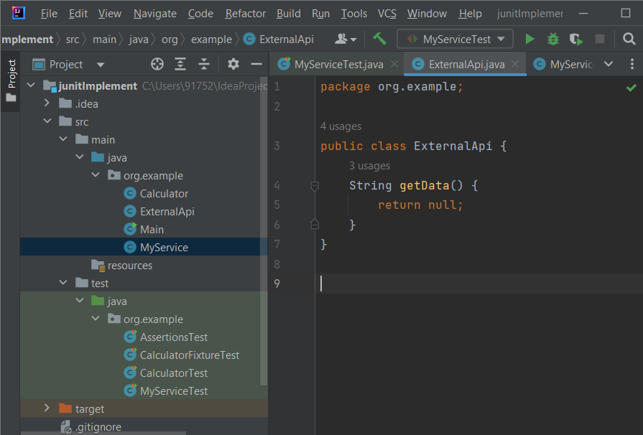

1. Output

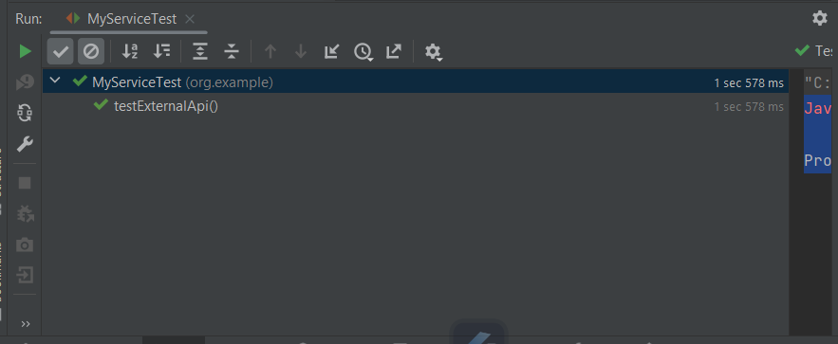

1. Pom.xml
2. <?xml version="1.0" encoding="UTF-8"?>  
   <project xmlns="http://maven.apache.org/POM/4.0.0"  
    xmlns:xsi="http://www.w3.org/2001/XMLSchema-instance"  
    xsi:schemaLocation="http://maven.apache.org/POM/4.0.0 http://maven.apache.org/xsd/maven-4.0.0.xsd">  
    <modelVersion>4.0.0</modelVersion>  
     
    <groupId>org.example</groupId>  
    <artifactId>junitImplement</artifactId>  
    <version>1.0-SNAPSHOT</version>  
     
    <properties>  
    <maven.compiler.source>14</maven.compiler.source>  
    <maven.compiler.target>14</maven.compiler.target>  
    <project.build.sourceEncoding>UTF-8</project.build.sourceEncoding>  
    </properties>  
     
    <dependencies>  
    <!-- https://mvnrepository.com/artifact/org.junit.jupiter/junit-jupiter-api -->  
     
    <dependency>  
    <groupId>org.junit.jupiter</groupId>  
    <artifactId>junit-jupiter-engine</artifactId>  
    <version>5.10.0</version>  
    <scope>test</scope>  
    </dependency>  
    <dependency>  
    <groupId>junit</groupId>  
    <artifactId>junit</artifactId>  
    <version>4.13.2</version>  
    <scope>test</scope>  
    </dependency>  
     
    <!-- Mockito -->  
    <dependency>  
    <groupId>org.mockito</groupId>  
    <artifactId>mockito-core</artifactId>  
    <version>5.8.0</version>  
    <scope>test</scope>  
    </dependency>  
     
    </dependencies>  
   </project

